In this essay, we construct an objective evaluation system to rank the roller coasters. We deem that what influences the ranking of a roller coaster can be its degree of stimulation and safety. We come up with 2 models to partly evaluate these two factors.

The first model is to evaluate the degree of the excitement. In this model, we consider that the general rails, the inversions, the material of the rail for the people’s personal preference and the riding pattern of the roller coaster. We calculate the excitement per unit of time to represent the excitement intensity, rank the riding patterns and calculate the relative weight of the materials by collecting the information online through internet crawl and normalize all these data and calculated results to get a final index about a roller coaster through coefficient of variation.

The second model concentrates on the safety, which connects to the age, building fund, the maintenance and the operation loss. We use multiplication method and the λ method to respectively calculate the safety index.

Then, we calculate the comprehensive evaluation index to rank the roller coasters and get the world’s top 10 roller coasters.

The third model is the basic concept for the app which could choose a best roller coaster for a roller coaster rider. Besides, we add the location into the consideration to choose a best roller coaster which is also suit in distance.

Finally, we do the sensitivity analyses to show the robustness of the models and give the concept of the app described above.

|  |
| --- |
| **Fly Over The Inversions**  **Team** #**8783**  **November 12th, 2018** |

Contents

1 Introduction 3

1.1 Background 3

1.2 Problem Restatement 3

1.3 Literature Review 3

2 General Assumptions 4

3 Model A: The “Excitement” of the Roller Coaster 4

3.1 Model Overview 4

3.2 Model Assumptions 4

3.3 Variable Table 5

3.4 Sub Model A: Preparation Model 5

3.4.1 The Ranking for Riding Type of the Coasters 5

3.4.2 The Construction of the Roller Coaster 6

3.4.3 The Normalization Process 7

3.5 Sub Model B: The Rail of the Roller Coaster 7

3.5.1 The Index of excitement 7

3.5.2 The Marginal Effect of Height 8

3.5.3 The General Rail 9

3.5.4 The Angle of Inclination 9

3.5.5 Modeling the inversions in ADAMS 11

3.7 The Inversions 12

3.6 Coefficient of Variation Method 14

4 Model B: The Index of Safety 14

4.1 Model Overview 14

4.2 Model Assumptions 14

4.3 Variables Table 15

4.4 Preparation Model 15

4.5 Index of Safety 15

4.5.1 Multiplication Method 15

4.5.2 λ Method 16

4.6 Model Conclusion 16

5 Model C: The basic concept of the App 18

5.1 Model Overview 18

5.2 Model Assumptions 18

5.3 Variables Table 19

5.4 The Concept of App 19

6 Sensitivity Analysis 20

7 Strengths and Weaknesses 21

News Release 22

References 24

# **1 Introduction**

## 1.1 Background

Roller coaster, which is popular among not only challengers who pursue the feeling of excitement but also many ordinary people. Some roller coaster ranking sites online determine the ranking of a roller mainly referring to the experience score of some “experts” as well as some of the objective factors. However, as the feeling varies from person to person, the ranking system should be able to describe the roller coaster more objectively, for which something more should be considered.

## 1.2 Problem Restatement

In this essay, we’ll build mathematical model to act as a ranking system to evaluate the quality of a particular roller coaster.

1. Build an objective quantitative mathematical model to develop a descriptive roller coaster ranking system based only on roller coaster numerical and descriptive specification data.
2. Use the mathematical model to develop the ‘top 10 Roller Coaster in the world’ list and compare the ranking result and descriptions from our model with at least 2 other ranking systems found online.
3. Describe the concept and design for a user-friendly app with our model to help a potential roller coaster rider find a roller coaster that she or he would want to ride.

## 1.3 Literature Review

While some roller coaster ranking websites evaluate the quality of a particular roller coaster through the score of experiencing roller coaster riders, which obviously seems not to be suitable for everyone, we thought it more flexible to give an objective ranking to such a roller coaster. In this essay, we will construct mathematical models taking more objective factors into account to give the accurate ranking to the roller coaster.

# **2 General Assumptions**

1. The excitement of a Roller Coaster is calculated for reference to the same person.

As the sense of excitement varies from person to person and we need to objectively describe the roller coaster, we calculate the excitement for reference to the same person to remove the subjective variable of different feelings among people.

1. **The danger is not considered as a part of excitement.**

The possibility of potential danger may lead some of the mass to feel excited, but this is a weird hobby. The majority of the mass values their life, so they will avoid the danger instead of going straight to it.

1. **We divide the quality of a roller coaster into two parts of excitement and safety.**

Usually, the challengers and tourists go to the roller coaster for pursuing the feeling of excitement, for which we take “excitement” as the important factor of a roller coaster. Besides, safety play an equally important role in the evaluation

# 3 Model A: The “Excitement” of the Roller Coaster

## 3.1 Model Overview

According to our assumption, we divide the quality of a roller coaster into two parts of the excitement and safety. In our first model, we make attempt to measure the ranking of excitement. It’s obvious that the sense of excitement is connected with the factors such as the height, drop, inversions and many other elements of the roller coaster. In this way, we’ll first investigate the effects of the length, the drop and the inversions. Next, we add the type and construction of the roller coaster into account and make it complete.

## 3.2 Model Assumptions

1. We consider the inversions of the roller coaster as a circle.

In order to calculate the impact of the inversions, we simplify the shape of the inversions as the circle, and it will have little effect on the result of the excitement.

1. **We divide the roller coasters into two parts of general rails and inversions.**

As most of the roller coasters consist of these two kinds of parts and stimulate the riders, we simplify the rail the roller coaster into these two parts.

## 3.3 Variable Table

**Table 1** Variables for Model A

|  |  |
| --- | --- |
| Variables | Definition |
| $$x_{i}$$ | The ranking for the ride pattern |
| S | The qualified index of excitement |
| a | The accelerate of the coaster |
| v | The velocity of the coaster |
| θ | The inclination of the rail |
| h | The height of the roller coaster |
| h’ | The height from the coaster to the highest height of the roller coaster |
| $$h_{l}$$ | The drop from the highest height of the roller coaster to the lowest one |
| l | The length of the roller coaster |
| $$γ$$ | The coefficient of variation |
| E | The total evaluation index of the excitement of the roller coaster |
| $$A_{i}$$ $$Y_{i}$$ | The weight of the factors  The relative weight of the materials |

## 3.4 Sub Model A: Preparation Model

### 3.4.1 The Ranking for Riding Type of the Coasters

The Roller Coaster has five riding patterns, which are Sit Down, Wing, Stand Up, Suspended, and Inverted. Each pattern of riding brings the rider with different ratio of simulation and the feeling of excitement. In this way, we rank these patterns into 5 levels. There’s no doubt that sitting down is the least level. The less a passenger is covered by carriage, the more chance she can rub with air and the more exciting the pattern is.

Therefore, we rank the five models in the following form.

**Table 2** The ranking for the Ride Pattern

|  |  |
| --- | --- |
| **Ranking** | **Ride Pattern** |
| $$x_{1}$$ | Sit Down |
| $$x_{2}$$ | Wing |
| $$x_{3}$$ | Stand Up |
| $$x_{4}$$ | Suspended |
| $$x_{5}$$ | Inverted |

$x_{i}$ (i =1 to 5) presents the excitement ranking of each model, whose value is: $$\left\{\begin{aligned}x_{1}=1 \\ x_{2}=2 \\ x_{3}=3 \\ x_{4}=4 \\ x_{5}=5\end{aligned}\right.$$

For the different factors have different dimension, and the value will influence the numerical evaluation result, we will normalize all of the data. Then we normalize these ranking with the equation:

$$x_{i}'=\frac{x_{i}-x_{min}}{x_{max}-x_{min}}$$

In this way, we can get the normalized data of the rank.

### 3.4.2 The Construction of the Roller Coaster

Besides the ranking of simulation itself will influence the roller coaster, we think the construction ingredient also plays a role in the evaluation of entertainment. As the technology and the age developing, it’s common and normal to build the roller coaster with steel for its strength and safety. While most of us think it strange to ride a roller coaster, there are still a few people who prefers wooden roller coaster, through which we can get that the construction materials will also have an impact which is positive in some case and negative in others on the ranking.

For this we use a web crawler to search the information on a roller coaster website to search the referring entry and compare the number of the persons preferring wooden ones and persons preferring steely ones to get the relatively weight of these two kind of roller coasters. We believe that the information got from big data can objectively reflect their weight.

Finally, we have found 9451 messages about the riders’ preferences about the materials of the roller coaster on some roller coaster concerned websites and get 3391 persons prefer wooden roller coaster and 6060 persons prefer the steely ones. In the later section we will use these data to get the relative impact of these two materials which is objectively relucted through the community.

Then we get their relative weight:

$$\left\{\begin{aligned}Y_{1}=\frac{3391}{9451}=0.358798 \\ Y_{2}=\frac{6060}{9451}=0.641201\end{aligned}\right.$$

### 3.4.3 The Normalization Process

For the different factors have different dimension, and the value will influence the numerical evaluation result, we will normalize all of the data so that we can eliminate the deviation resulting from the data’ different dimension. We do the normalization process thorough the equation:

$$x_{i}'=\frac{x_{i}-x_{min}}{x_{max}-x_{min}}$$

## 3.5 Sub Model B: The Rail of the Roller Coaster

### 3.5.1 The Index of excitement

When we get on a Roller Coaster, the reasons why we feel excited are the high position which makes us feel scared, the feeling of pushback which caused by acceleration, and the rapid velocity that makes us feel the wind. Therefore, the Index of excitement can be influenced by the related height from floor, which is h, the acceleration of that moment, which is a, and the velocity at that moment which is v. Based on those, the Index of excitement s can be expressed by the following equation:

$$S=f(a,v,θ,h)$$

It’s hard to qualify the excitement, as it’s a subjective feeling of a person. As we define current intensity as the amount of charge passing per unit of time to describe the strength of current, we define the excitement intensity as the excitement feeling which a person gains per unit of time. In this way, we need to get the total quantity of the excitement, for which we first calculate the integral of S over the length of the roller coaster.

$$\int_{0}^{l}{s}=\int_{0}^{l}{(a+v+θ+h)dl}$$

Then we get the excitement intensity:

$$I=\frac{\int_{0}^{l}{s}}{t}$$

### 3.5.2 The Marginal Effect of Height

Usually, as the height of the roller coaster rises, the more excitement the costumers will feel. However, when it rises to a certain height, the decrease of the excitement doesn’t seem to be as quick as before, for which it is almost the same in the situation of being in the height of 300m or 8844m, the marginal effect of height shouldn’t be ignored. And it should be like the figure below:

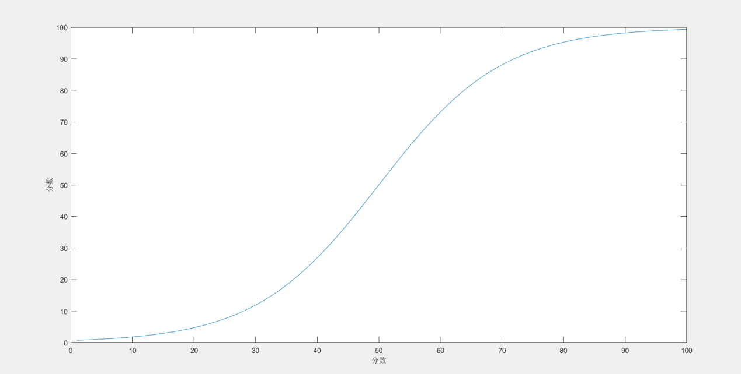

**Figure 1 Logistic growth function**

Therefore, the graph of height should be a logistic equation.

$$\frac{∂S}{∂h}=h(S_{max}-h)$$

In this equation, the c represents the peak of the excitement as the height rising, and the a, n is the constant in the equation. For we have done the normalization process, the $S_{max}$ is 1.

In this, we can get the expression:

$$\int_{0}^{l}{S}=\frac{l}{e^{1-h_{l}}+1}+c$$

In this equation, the c represents the other factors which will be discussed later.

### 3.5.3 The General Rail

The most common simulation giving to the riders is the rail. The general rail simulates the riders through the drop which mainly gives the coaster accelerate and the velocity. As we can easily get the expression of accelerate and velocity:

$$\left\{\begin{aligned}a=g\sin{θ} \\ v=\sqrt{2gh^{'}}dh^{'}\end{aligned}\right.$$

Then we get:

$$dS=\left(g\sin{θd_{θ}+}\sqrt{2gh^{'}}dh^{'}\right)dl$$

$$S=\int{gsinθ{d_{θ}dl+}\int{\sqrt{2gh^{'}}}}dh^{'}dl+c$$

$$\int_{0}^{l}{S}=\iint{gsinθ{d_{θ}dl+}}\iint{\sqrt{2gh^{'}}dh^{'}dl}+c$$

For:

$$\frac{\iint{g\sin{θd_{θ}dl}}}{\int{θ_{l}dl}}=\frac{g\int_{0}^{θ_{0}}{-cosθ}}{\int_{0}^{θ_{0}}{θ}}$$

When the length of the rail changes, the changing process of the rail must be a gradual change. In this way, we can get:

$$\int_{0}^{θ_{0}}{θ_{l}dl=\frac{1}{2}}θ_{0}l$$

$$\iint{g\sin{θd_{θ}dl}}=\frac{2g-2cosθ_{0}g}{θ_{0}^{2}}∙\frac{l}{2}θ_{0}=\frac{\left(g-cosθ_{0}g\right)l}{θ_{0}}$$

And we get the final expression of the excitement index:

$$\int_{0}^{l}{S}=\frac{\left(g-cosθ_{0}g\right)l}{θ_{0}}+\frac{2}{3}\sqrt{2g}lh_{l}^{\frac{3}{2}}+c$$

### 3.5.4 The Angle of Inclination

The rail influences the experience of the riders as they can feel different kinds of scaring of different directions. As the person inclines, the feeling of excitement appears. The more it inclines and the more the distance from the vertical angle, the more uncommon and excited will the readers get. Commonly, we can divide the angle of inclination into such 4 kinds:

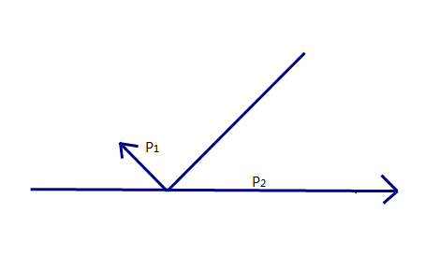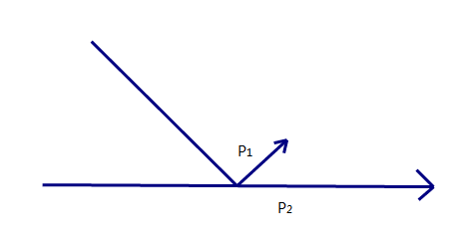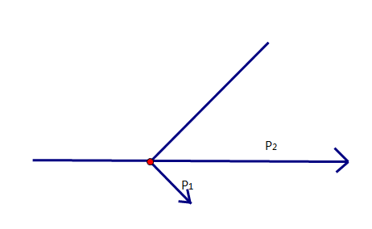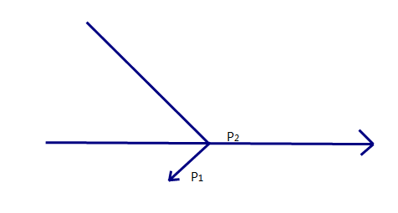

**Figure 2-5** The Simply Drawing for Rail and Person

As these 4 pictures show, the direction of the person’s head is the vector p1, and the horizontal rail is the vector p2. We can easily identify that when it’s the situation a1, the person is simulated most, for he is inverted and diving into the lowest height and can experience both enjoyment. And the next can be ranked in the order of a2, a3, a4, for that the person is inverted or diving into the ground.

In this section, we use the multiplication cross of the p1 vector and the p2 vector to qualify the relatively impact of them to reflect the impact of the inclination angle. In order that the result can match the result above of general cognitive, we formulate the function below:

$$\frac{∂S}{∂θ}=-d\vec{p_{1}}×d\vec{p_{2}}*\frac{sin\frac{θ}{2}}{cos⁡θ}dθ$$

We formulate this function in which the inner product vector’ direction is positive when it points down and it will rise as the θ increases because of the $sin\frac{θ}{2}$ so that it can conform to the result of common sense.

In this way, we finally get the expression of excitement index and the inclination angle:

$$\int_{0}^{l}{S}=\iint{-d\vec{p_{1}}×d\vec{p_{2}}*\frac{sin\frac{θ}{2}}{cos⁡θ}dθ}+c$$

$$\int_{0}^{l}{S}=\sqrt{2}\operatorname{arctanh}\left(\sqrt{2}\cos{\frac{θ_{0ss}}{2}}\right)l+c$$

Then, we can get the final expression of the excitement index:

$$\int_{0}^{l}{S}=\frac{\left(g-cosθ_{0}g\right)l}{θ_{0}}+\frac{2}{3}\sqrt{2g}lh_{l}^{\frac{3}{2}}+\frac{l}{e^{1-h_{l}}+1}+(ζ-\sqrt{2}\operatorname{arctanh}\left(\sqrt{2}\cos{\frac{θ_{0}}{2}}\right))l$$

In the equation, ζ represents a constant as a result of the integral which is about 1.2465.

### 3.5.5 Modeling the inversions in ADAMS

By utilizing ADAMS, we established our 3D virtual Roller Coaster model, which contains a model of carriage, a model of rail, a model of wheels, a model of friction. The friction is approaching to Havised's identity step function by a three-degree polynomial.

The function of friction is customized as the following:

SFORSE=STEP (VM,0,0,0.5, SIGN(0.0001 $∙$ PCTV-VX))

In which ,0.0001 means Rolling friction coefficient. The function above meets the actual features of frictions, which is proportional to the pressure, opposite to the moving direction. It equals to 0 when there is no moving potential.

The rail is a 3D curve, which is a rigid body without weight. A software under ADAMS called solid-work. The wheels and the rail are restrained by the movement of Tip cam.

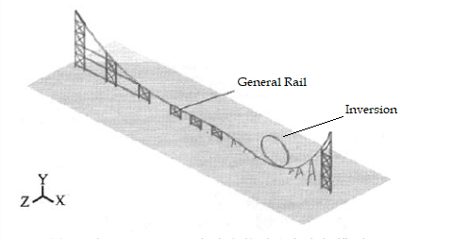

**Figure 6** The Simulation Model

### 3.7 The Inversions

The inversions of the roller coaster influence the feeling of excitement in the same way as the general rail which is determined by the accelerate, velocity, inclination angle and the height. Then, we will search for the radius of the inversion circle to calculate the excitement index of the inversions.

According to the  [theorem](javascript:;) [of](javascript:;) [kinetic](javascript:;) [energy](javascript:;), we can easily get the stress condition of the coaster when it’s on the inversion:

$$\left\{\begin{aligned}m(\frac{v^{2}}{r})≥mg \\ \frac{1}{2}mv^{2}=mgh-mg∙2r-W_{f}\end{aligned}\right.$$

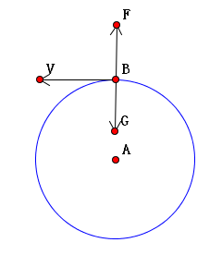

**Figure 7** The Stress Condition of the Inversions

$W_{f}$ is the work of the friction. As we have got the friction in the ADAMS, we can calculate that: $$r≤\frac{2}{5}h$$

$$d≤\frac{4}{5}h$$

The biggest [gravitational](javascript:;) [acceleration](javascript:;) a person can bear rage from 6g to 7g. To get the best radius which can give the person the most simulation, we use MLE(maximum likelihood estimation) to get the best [probability](javascript:;) [distribution](javascript:;) which can last at the [gravitational](javascript:;) [acceleration](javascript:;) rage from 6g to 7g. According to the definition of MLE:

$$β=argmax\prod_{1}^{m}{(x^{i},β)}$$

And then we substitute our variables, we can get:

$$β=argmax\prod_{6g}^{7g}{(a,β)}$$

As the expression of a can be easily got through the Centripetal force formula, we use SPSS to calculate the date from 0 to $\frac{2}{5}h$, we finally get that the best radius for the inversion circle is $\frac{1}{3}h$. In this way, we can get the excitement index of the inversions:

$$\int_{0}^{2πr}{S}=\frac{\left(g-cosπg\right)2πr}{π}+\frac{2}{3}\sqrt{2g}*2r*{\left(2r\right)}^{\frac{3}{2}}+\frac{l}{e^{1-2r}+1}+(ζ-\sqrt{2}\operatorname{arctanh}\left(\sqrt{2}\cos{\frac{θ_{0}}{2}}\right))2πr$$

## 3.6 Coefficient of Variation Method

As we have normalized all the data, we just need to ascertain their weight in the evaluation system. For we can objectively reflect the weight of the elements, we use the Coefficient of Variation Method to do this. It can give the weight of a factor only according to the data. We can first calculate the coefficient of variation of a factor through the equation:

$$γ=\frac{\sqrt{\frac{1}{n}\sum_{i=1}^{n}{(x_{i}^{2}-{\overline{x}}^{2})}}}{\overline{x}}$$

Then we can get the weight of the factor:

$$A_{i}=\frac{γ_{i}}{\sum{γ}}$$

Finally, we can get:

$$E=A_{1}I+A_{2}M+A_{3}x_{i}'$$

We have calculated that $γ_{1}=1.17568$, $γ_{2}=0.5103$ and $γ_{3}=0.1293$.

And then we can get that $A_{1}=0.6476$, $A_{2}=0.28111$ and $A_{3}=0.07122$

# 4 Model B: The Index of Safety

## 4.1 Model Overview

Besides the excitement of the roller coaster, the safety also plays an important in the evaluation system. To rank the safety index of the roller coaster, we build the model considering the strength of the rail and the braking time and other indexes. Then, we dividedly use two methods to construction the evaluation system to get the ranking.

## Model Assumptions

1. We evaluate the safety of a roller coaster through the maintenance cycle and fund.

As all of the roller coasters’ safety must be over the international safety index and it’s unlikely to have an accident, we evaluate this index mainly through the maintenance cycle and fund to describe the strength of the rail and coasters.

1. We don’t consider the factors of weather, climate and terrain.

As we only evaluate the safety according to the roller coaster itself, these objective factors are not taken into our account.

## 4.3 Variables Table

**Table 3** Variables for Model A

|  |  |
| --- | --- |
| Variables | Definition |
| t | The age of the roller coaster |
| s | The maintenance cycle of the Roller Coaster |
| j | The maintenance funds of the Roller Coaster |
| e | The total cost of the Roller Coaster |

## 4.4 Preparation Model

The physical sample of ‘Single Ring Pulley’ is 1500kg when fully loaded. In the ADAMS model above, we can figure out the friction braking force by calculating the function below:

$$F=STEP(DX,10,STEP\left(VX,-0.01,0.2∙DV_{1},0,0\right),10.1,0)$$

After simulation experiment, it matches the actual feature of movement. The friction braking force is proportional to the pressure. When the speed is 0, the friction braking force reaches 0 either.

We utilized ADAMS to figure out the braking time, when the pressure is 20000N or40000N or 60000N or 80000N. Since the Roller Coaster decelerates 30s before it arrives the terminal station, the best deceleration time should be 30s.

## 4.5 Index of Safety

To reflect the effect of the factors we consider, we formulate 4 linear function:

$$\left\{\begin{aligned}g_{1}\left(t,v\right)=-vt+1 \\ g_{2}\left(t,h_{l}\right)=-h_{l}t+1 \\ g_{3}\left(j,s\right)=js+1 \\ g_{4}\left(t,e\right)=\left(1-t\right)e\end{aligned}\right.$$

### 4.5.1 Multiplication Method

In the first method, by utilizing multiplication method, we can figure out the maximum value of comprehensive assessment.

$${f_{1}=g}_{1}\left(t,v\right){∙g}_{2}\left(t,h_{l}\right){∙g}_{3}\left(j,s\right){∙g}_{4}\left(t,e\right)$$

The advantage of this method is that the weight of each object is not required. Meanwhile, the weights are subjective. If one of the functions reach 0, the f will reach 0 too.

### 4.5.2 λ Method

In the second method, which is called $λ$ method, we are trying to figure out the maximum of each function and create a new function. In this function, because of the differences of the dimensions, we use the coefficient ${ λ}_{i}$ to make the data in the same order of magnitude.

$${f_{2}={ λ}_{1}g}_{1}\left(t,v\right){+{ λ}_{2}g}_{2}\left(t,h_{l}\right){+{ λ}_{3}g}_{3}\left(j,s\right){+{ λ}_{4}g}_{4}\left(t,e\right)$$

In which,

$${ λ}_{i}=\frac{1}{g_{i}^{0}}$$

$$g_{i}^{0}=maxg_{i}(x,y)$$

## 4.6 Model Conclusion

Finally, through the index of excitement and safety, we can get the final index

**Table 4** The ranking of the top 10 Roller Coasters in the world

|  |  |
| --- | --- |
| 1、Top Thrill Dragster | 0.709594026 |
| 2、Red Force | 0.708215857 |
| 3、Superman: Escape from Krypton | 0.704817736 |
| 4、Tower of Terror II | 0.704817736 |
| 5、Fury 325 | 0.7041254 |
| 6、Steel Dragon 2000 | 0.701247103 |
| 7、Millennium Force | 0.700880073 |
| 8、Leviathan | 0.699721582 |
| 9、Intimidator 305 | 0.499245277 |
| 10、Kingda Ka | 0.486508062 |
|  |  |

**Figure 8** The ranking of the top 10 Roller Coasters in the world

The following two figures are the top 10 roller coasters online.

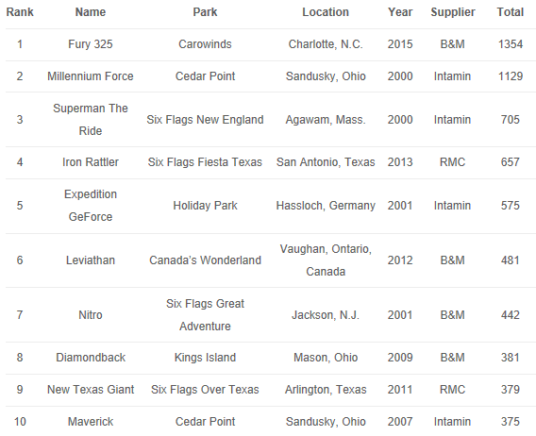

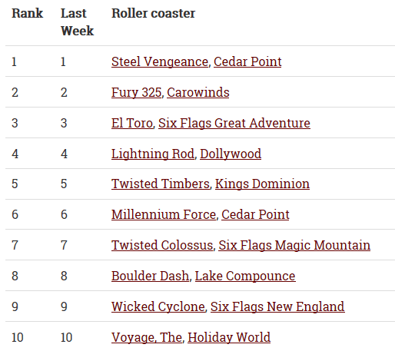

**Figure 9,10** The ranking of the top 10 roller coasters found online

The Fury 325, Millennium Force, Leviathan are the same in our result and the two other rating systems found online. The different result is because we considered the factor of safety, and our result is based on objective measures.

# 5 Model C: The basic concept of the App

## 5.1 Model Overview

In our previous models, we only measure the score of the roller coasters in objective aspects. But in this app, we need make it suitable for every user, so we make some changes base on our previous models.

## 5.2 Model Assumptions

1.We consider that all the users are wise choosers.

*Since that the majority of the people won’t be too extreme to experience the best roller coaster, so we consider that they are all wise choosers that they will take the distance into consideration to simplify our model.*

## 5.3 Variables Table

**Table 5** Variables for Model C

|  |  |
| --- | --- |
| Variables | Definition |
| s | The entertainment point |
| F  E  E’ $$N_{i}$$ $$P_{i_{j}}$$ | The safety point  The entertainment relative difference  The safety relative difference  The number the user i input  The score of the roller coaster for the user i |

## 5.4 The Concept of App

We first let the user choose the material and the riding type of the roller coaster instead of measuring them in objective methods. And we define the entertainment point as:

$$s=S-f$$

Meanwhile, we define the safety point as:

$$F=f-S$$

Then we define the entertainment and safety relative difference as:

$$E=\frac{100}{s_{max}}*s$$

$$E^{'}=\frac{100}{F_{max}}*F$$

Users can choose an integer from 0 to 100. If the number is on the left, it means that it is safer; if it is on the right, it means more entertain. And we remember the number the user i inputs as Ni, which is above zero when it is closer to entertainment and below zero when it is closer to safety.

Then we define the score of the roller coaster j to the user i as:

$$P_{i_{j}=\left\{\begin{aligned}-[\left(N_{i}-E\right)+R_{i_{j}}] \\ -[\left(N_{i}-E'\right)+R_{i_{j}}]\end{aligned}\right.}$$

Which $R_{i_{j}}$ refers to the distance between the user I and the roller coaster j.

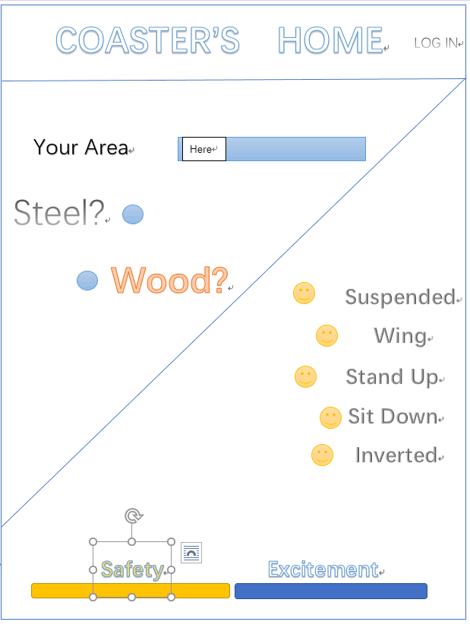

**Figure 11** The showing picture of our app

# 6 Sensitivity Analysis

6.1 The Sensitivity Analysis about the A1

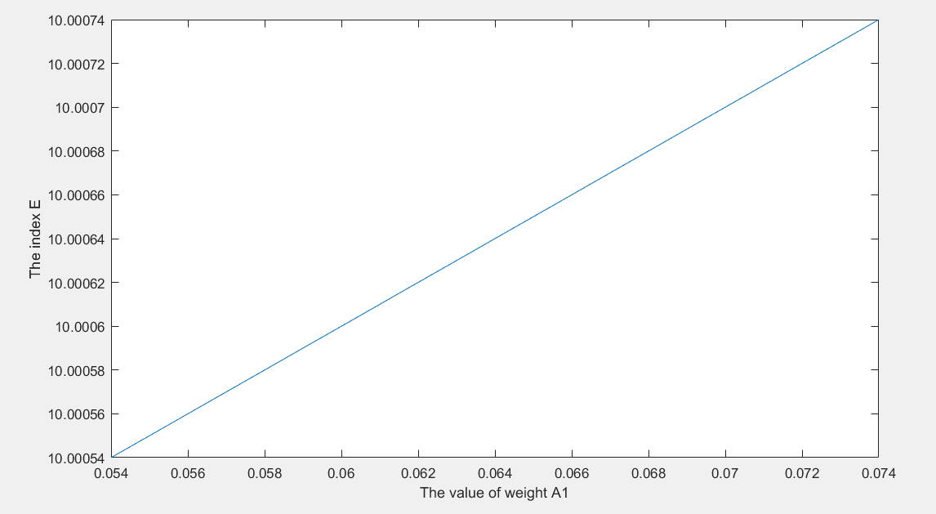

**Figure 12** The Sensitivity Analysis about A1

We do the sensitivity analysis about the weight $A_{1}$, and we find that the change is a little cute. However, as the weight changes in this line, the result of our model will not change much. So we think that our model is stable and robust.

# 7 Strengths and Weaknesses

We consider our model thoroughly and analyze them. Then we find some strengths and weakness, which is shown below.

**7.1 Strengths**

•• Universality

We made a special analysis and build a mathematical model for all kinds of condition, which makes our models have a high universality.

•Completeness

Besides the factors mentioned in the problem, we also take the conversion between two images and aesthetics into consideration. We tried to figure out every factor with our rigorous mathematical models so as to reach a more reliable and eligible result. Furthermore, we bring forward an evaluation and several suggestions, which grants our result diversity.

• User-friendly

In our design for application, we give out user-friendly options which meet the different demands. Our users can change the weights of excitement and safety which they can find the best Roller Coaster to them.

7.2 Weaknesses

Not enough Roller Coaster Candidates

Only 300 huge Roller Coasters given in the problem list is involved in our model, some of the Roller Coasters may be left out.

# News Release

**For Immediate Release**

**A group of Mathematical Modeling lovers introduce a new solution in choosing roller coasters**

12, November

We construct an objective evaluation system to rank the roller coasters. In our consideration, we think that what influences the ranking of a roller coaster can be its degree of simulation and the safety. We come up with 2 models to partly evaluate these two factors.

We evaluate the degree of the excitement and safety that the roller coaster brings the riders. We consider that the general rails of roller coasters, the inversions, the material of the rail for the people’s personal preference and the riding pattern of the roller coaster. The second model concentrates on the safety, which connects to the age, building fund and the maintenance and the operation loss. We use multiplication method and the λ method to respectively calculate the safety index.

Then, we calculate the comprehensive evaluation index to rank the roller coasters and get the world’s top 10 roller coasters.

The third model is the basic concept for the app which could choose a best roller coaster for a roller coaster rider. Besides, we add the location into the consideration to choose a best roller coaster which is also suit in distance.

Finally, we do the sensitivity analyses to show the robustness of the models and give the concept of the app described above.



# References

[1] Roller Coaster Database, [https://www.rcdb.com.](https://www.rcdb.com/)

[2] Roller Coaster and Amusement Park Database,

<https://www.ultimaterollercoaster.com/>

[3] Coasterpedia The Roller Coaster Wiki, <https://coasterpedia.net/>.

[4] <http://themeparkreview.com/>

[5] https://www.coastercrazy.com/